SPOOKY WOOKY HALLOWEEN CAMPOUT
September 26-28, 2025 699 Norfolk County Road # 28, Fairground , Ontario
Ghoulish Games, Trick or Treating, Movie & Popcorn, Costume Parade & Contest, Pancake Breakfast, Site Decorating Contest, Pumpkin Decorating Contest, Graveyard Card Bingo, Wicked Washer Toss Washrooms & Dump station provided ( but no showers) Fresh water available on site. 15 amp sites (20 amp if you have adaptor)
Camping for Weekend…………………… $60/unit Not camping but want to attend? $10/family
What to Bring: *enough water to last the weekend. (Water available at hall for fill-ups) *candy to hand out to the little “trick or treaters” * enough personal food for the weekend *Halloween costumes for the parade and contest *one pumpkin/ child for the pumpkin decorating contest plus carving tools * Halloween decorations for your campsite
Send registration info to Shelley Scott- myemmie1@gmail.com Bring $60 cash or cheque to the campout. Make cheques payable to Tri-County Travellers.
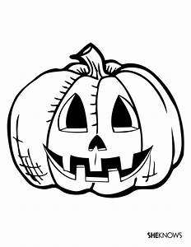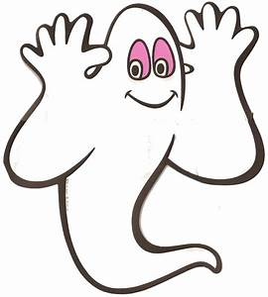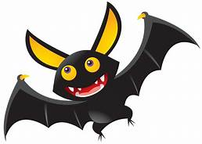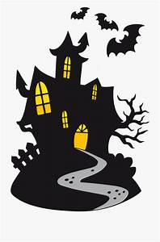

Name: ______________________________________________________________________________ Address:_____________________________________________________________________________ Email:______________________________________________________________________________ #Adults_______ #Teen______ #Youth_______ Ages of Youth_______________________________________

